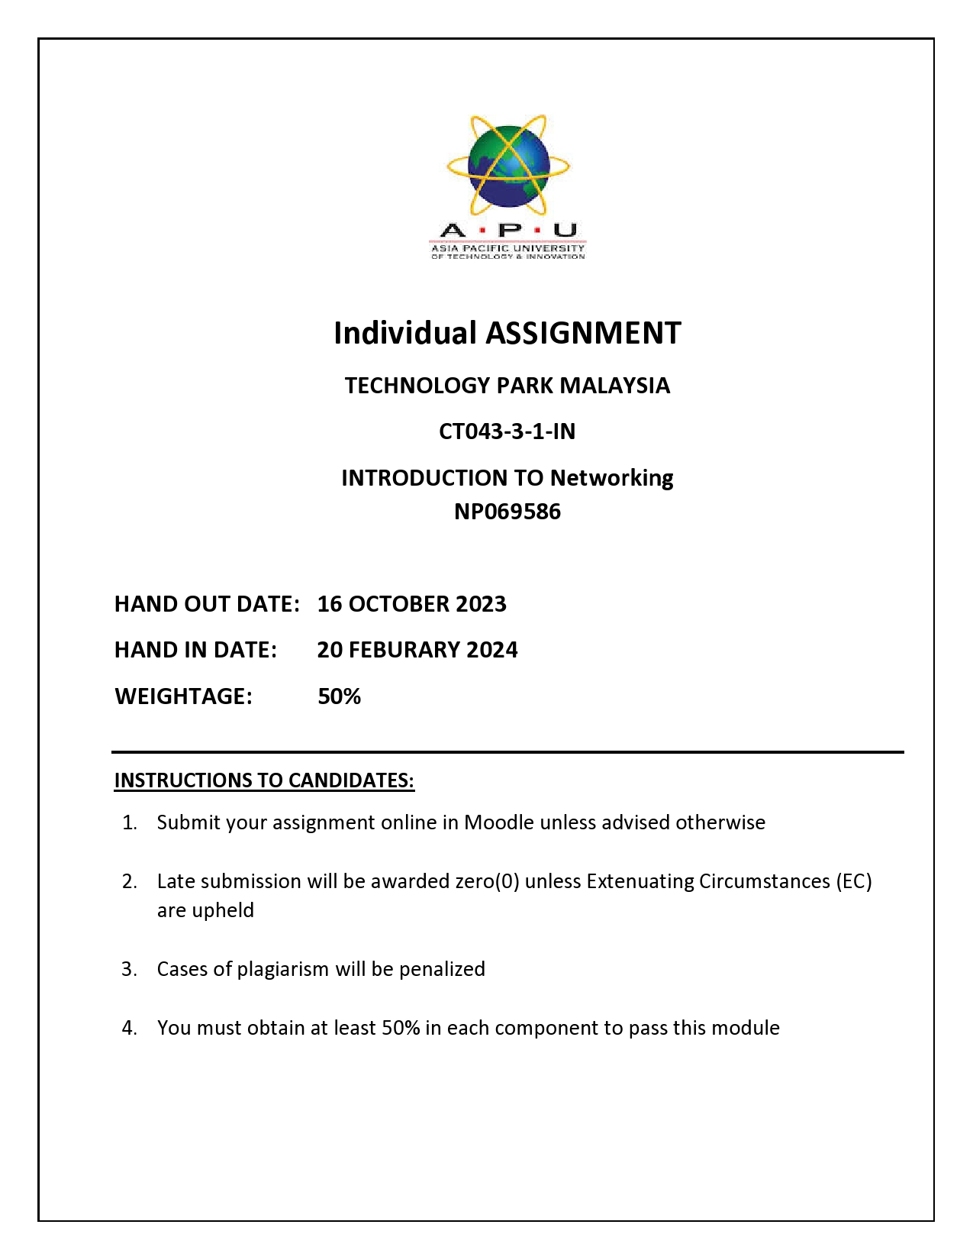

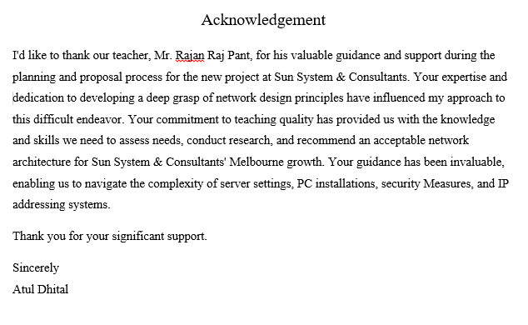

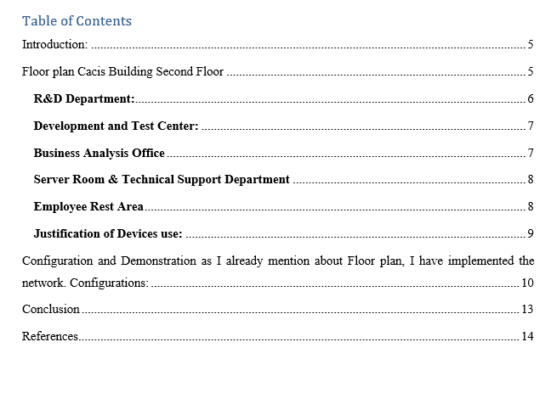

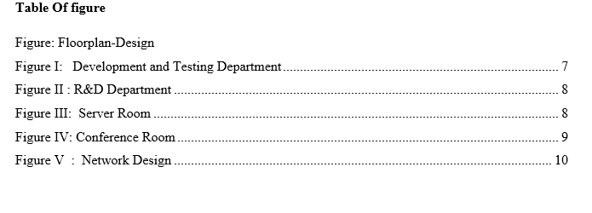

# Introduction:

Sun System & Consultants is a well-known IT service provider that is expanding a branch in Melbourne. The Harper and Cacis buildings each have two stories, while the Cacis Building has a second story.   
A network is a collection of two or more computers that are linked together to share resources (such as printers or CDs), exchange files, and facilitate electronic communication.

Computers in a network can connect with one another by cables, telephone lines, radio waves, satellites, or infrared laser beams (fcit.usf.edu/, n.d.).

# Floor plan Cacis Building Second Floor



Fig: Cacis 2nd floor design

“As a network designer I need to insure all the devices need to work properly and manage all the room as the floor plan requirement of Cacis Building Second Floor.

The Cacis building's second level contains seven rooms, including an employee break area where staff may rest, a research and development department that focuses on ERP system development, and a test and laboratory room.

A development system that works with the R&D department, a server room that is the heart of network management, a technical assistant room that handles all technical needs, a business analyst department that evaluates and improves each department's performance, and a large group and meeting room. The conference room is available. Our firm employs a PC and has a decent office environment; each department is equipped with a VoIP (Voice over Internet Telephone) for intercommunication and network-connected printers.  
In the staff rest are they can rest inside the room also we have bed and first aid if any staff get health emergency. This floor has key areas including business analyst, development and testing, technical assistant, conference, and server rooms, all with high-speed computers for optimal performance and comfort. We also have video monitoring and security to protect employees and businesses, and all units are linked to a master switch that links to the main router on the floor. The Brother trademark is found on a wide range of electronic equipment, including printers and scanners. The staff break area has an LG TV for amusement, and WiFi has been provided for satellite TV. The Technical Assistant Room has a computer workstation, video surveillance, a scanner, a printer, and a sofa. The Research and Development Department consists of seven computers for staff. The conference includes a projector, computers, and a wide conference table for presenting and discussing work. The server room has three office servers and one server with additional business PCs. The staff bathroom has Wi-Fi, and a small table where employees may take a rest.”

## **R&D Department:**



Figure R&D Department

## **Development and Test Center:**



Figure 1Development and Testing Department

## **Business Analysis Office**



Figure II

## **Server Room & Technical Support Department**

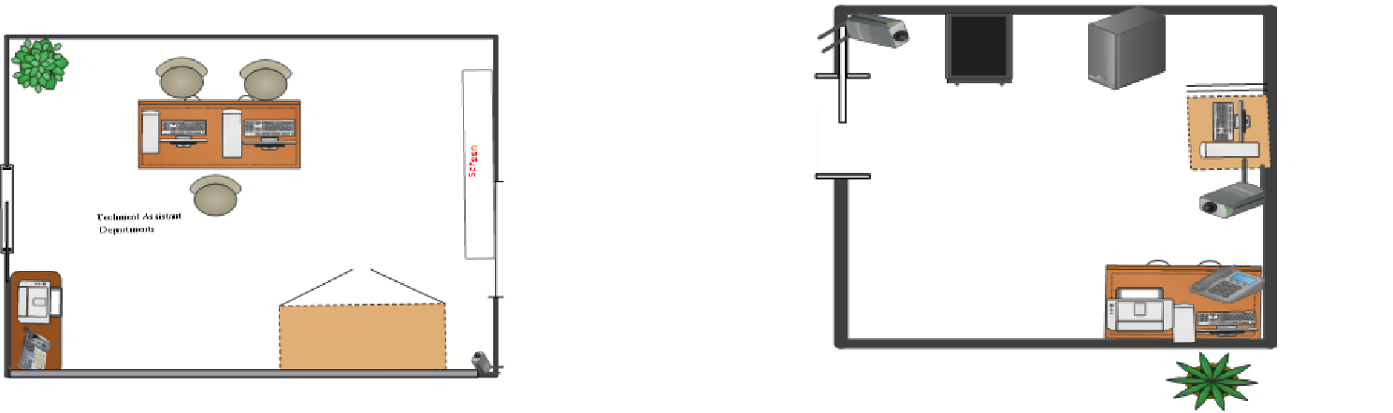

Figure III

## **Employee Rest Area**



Figure IV

**Network Design Cacis Building Second Floor**

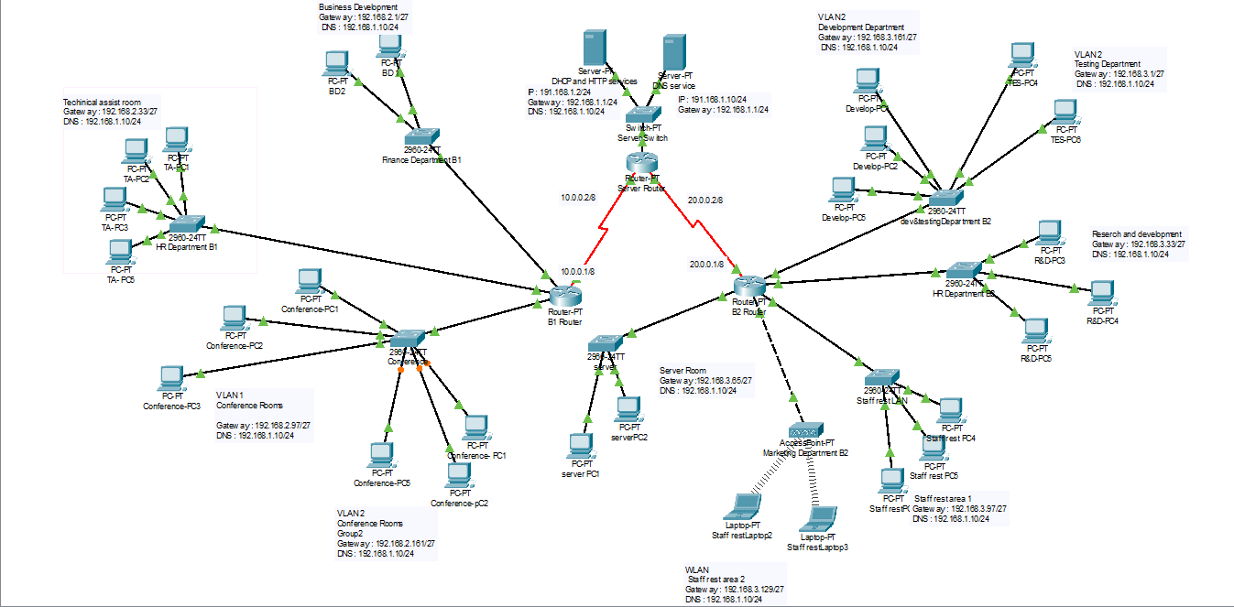

Figure V

## **Justification of Devices use:**

**Router:** A router connects two or more packet-switched networks or subnetworks (cloudflare, n.d.) . I used cisco router because it is easy to configure and less cost.

**Switch:** A network switch connects devices in a network and lets them interact by transferring data packets. Switches may be both hardware devices that manage actual networks and software-based virtual machines. I chose the Cisco Switch 2900 series because it is simple to configure and affordable.

**DHCP Server:** A DHCP server is a network server that dynamically assigns IP addresses, default gateways, and other network configurations to client devices. It responds to broadcast questions from clients over the Dynamic Host Configuration Protocol (infoblox.com, n.d.).

# Configuration and Demonstration as I already mention about Floor plan, I have implemented the network. Configurations:

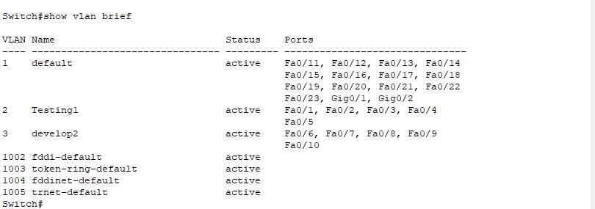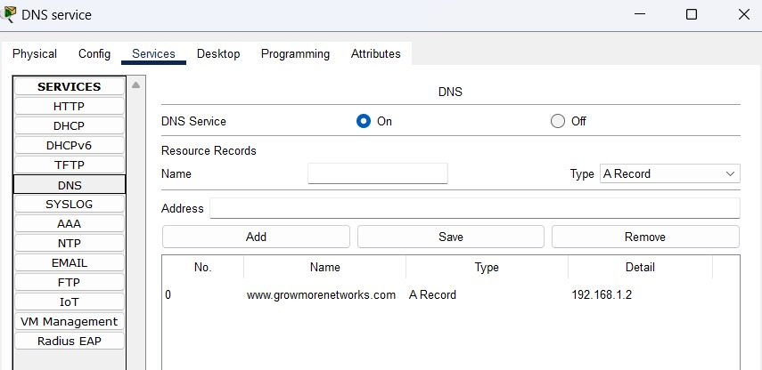

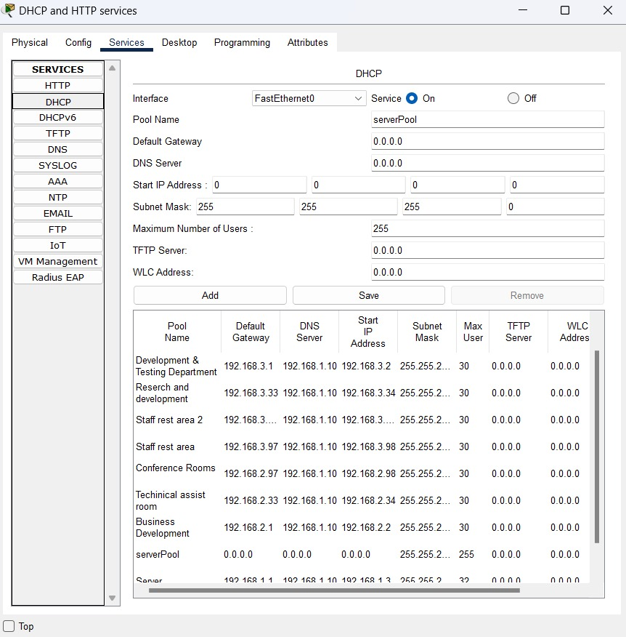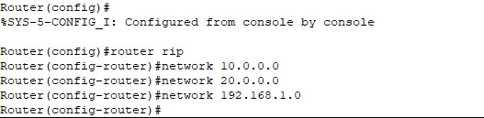

**Demonstration**

|  |  |  |  |
| --- | --- | --- | --- |
| S.N | Test Type | Description | Image |
| 1 | Internal Test | From R&D Department 192.168.2.1 to Server Room 192.168.3.66 |  |
| 2 | Internal Test | From Server room to  Development And Testing |  |
| 3 | Internal Test | From server to Staff rest area |  |
| 4 | Internal test | From Business Development to Conference room |  |
| 5 | Internal Test |  |  |

# Conclusion

This part of group project allowed me to learn about how IP works, how to work effectively in a group, how to make a floor plan, which was important for developing a networking concept, and how each IP communicates with one another via IP configuration.

# References

cloudflare. (n.d.). *cloudflare*. Retrieved from https://www.cloudflare.com/: https://www.cloudflare.com/learning/network-layer/what-is-a-router/

fcit.usf.edu/. (n.d.). *fcit.usf.edu*. Retrieved from https://fcit.usf.edu/: https://fcit.usf.edu/network/chap1/chap1.htm

infoblox.com. (n.d.). *What is DHCP Server?* Retrieved from https://www.infoblox.com/glossary/dhcp-server/#:~:text=A%20DHCP%20Server%20is%20a,to%20broadcast%20queries%20by%20clients.

techtarget.com. (n.d.). *What is a network switch?* Retrieved from techtarget.com: https://www.techtarget.com/searchnetworking/definition/switch